L2 – Database

CDM:
The CDM shows which table stores which entity that must be saved in the database and explain how each table works with each other.
Tables Needed:
- Consumer:
  - IDs
  - Usernames
  - Full names
  - Email address’
  - Admin rights
- Station:
  - Serial Numbers
  - Names
  - Descriptions
- Collection:
  - IDs
  - Names
  - Descriptions
- Measurement:
  - IDs
  - Time Stamps
  - Temperature readings
  - Humidity readings
  - Pressure readings
  - Light readings
  - Air quality readings

- Relationship Decisions:
- Consumer-Station: Two distinct relationships
  - Administers (1 : M): Admin who administrates the station.
  - Owns (1 : M): Regular user who owns the station.
- Consumer-Consumer: Friendship system (M : M)
  - Allows to add friends to users.
- Consumer-Collection: Multiple relationships
  - Creates (1 : M): Primary collection owner
  - Shares (M : M): Other consumers with access
- Collection-Measurement: M : M relationship
  - Measurements can belong to multiple collections
- Station-Measurement: 1 : M relationship
  - Each measurement originates from a specific station

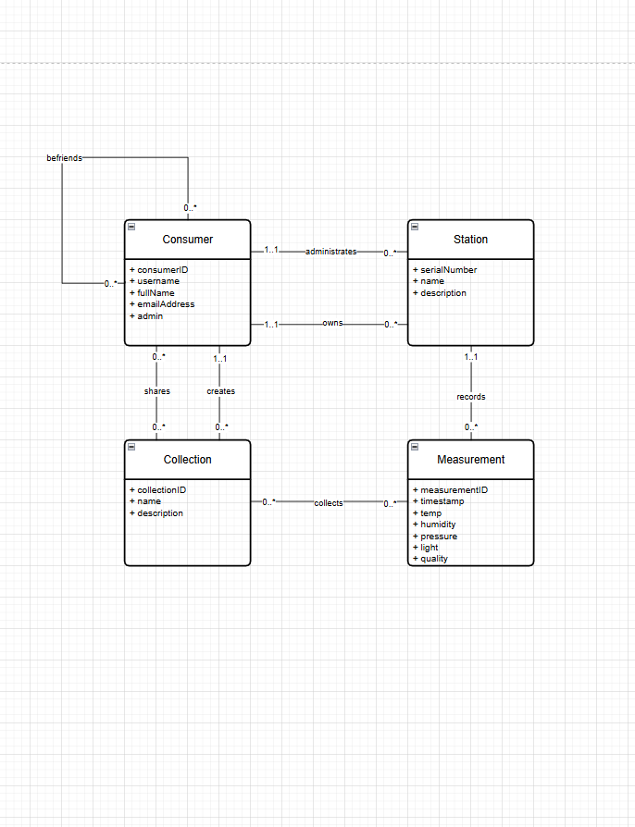
LDM:
The LDM refines the CDM into a database-agnostic structure with data types:
Key Improvements from CDM to LDM:
- Attribute Specification: Added data types and sizes
- Relationship Clarification: Added foreign key identifiers
- Bridge Tables: Explicitly defined N:M relationship tables
Design Decisions:
- befriend table: Represents friendships
  - Two foreign keys to consumer table
  - Created timestamp for relationship history
- shares table: Collection sharing system
  - Tracks who can access which collections
  - Timestamp for audit trail
- collect table: Collection-measurement membership
  - Enables flexible curation of measurements

